**🏠 Landing Page — Clinic Website Home**



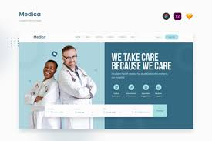



5

**What it does:**

✔ Introduces clinic  
✔ Patient signup & login  
✔ Service overview  
✔ Trust-building UI

**🧑‍💼 Admin Dashboard — Clinic Control Panel**

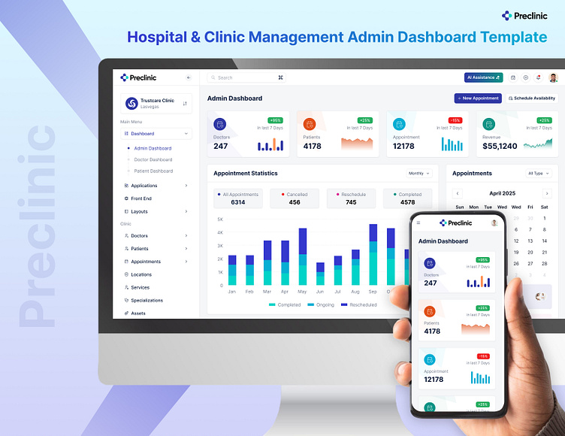

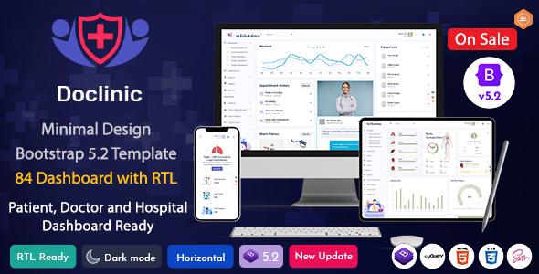

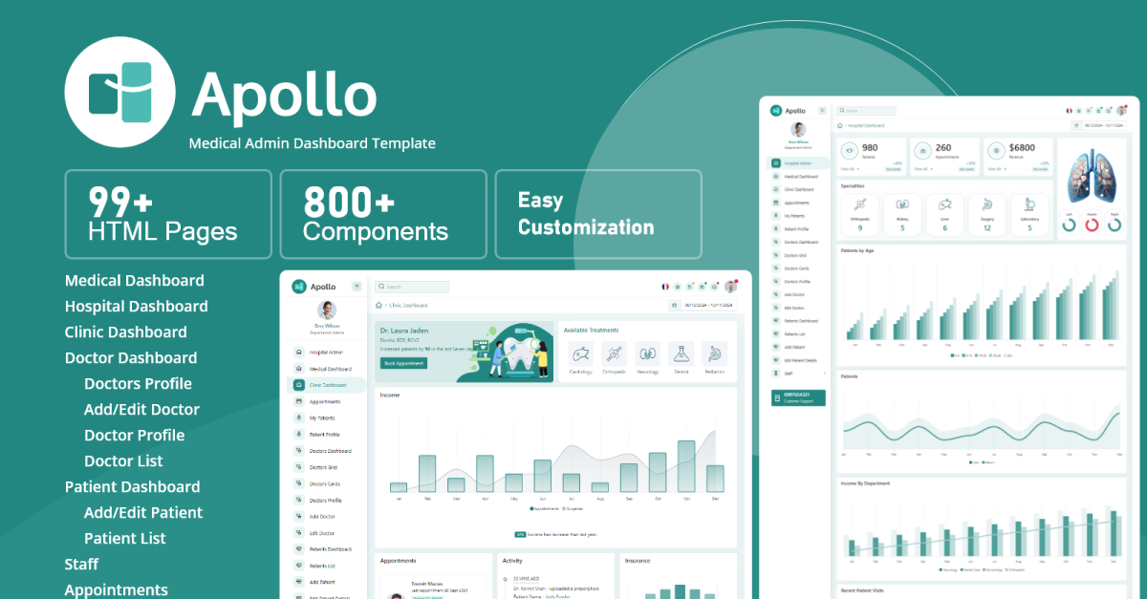

5

**Admin can:**

✔ Manage doctors  
✔ Track patients  
✔ View appointments  
✔ Control services

**👨‍⚕️ Doctor Dashboard — Daily Workflow**

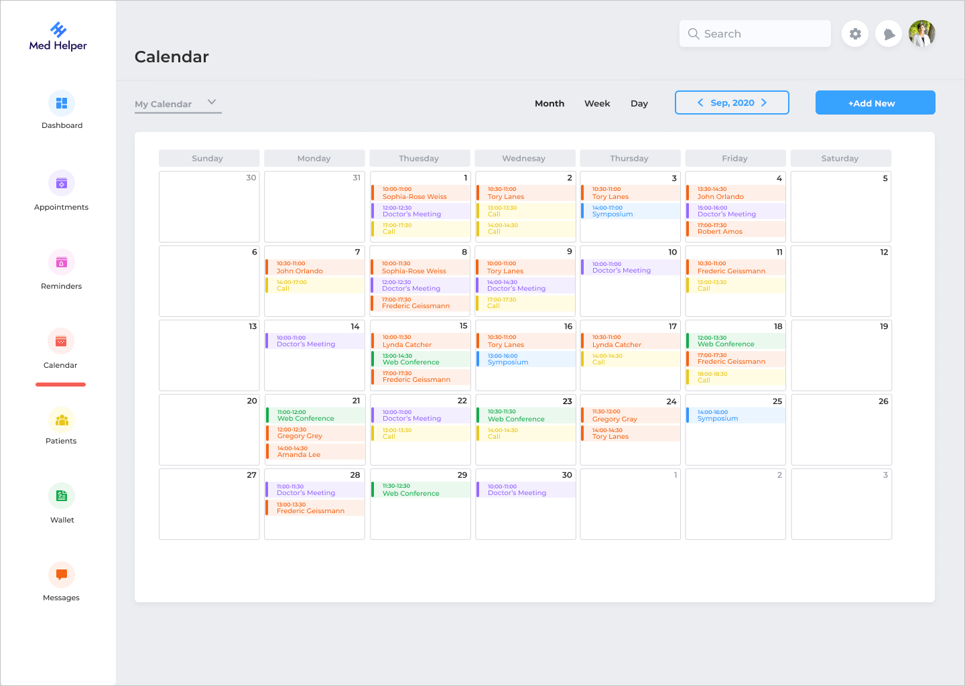

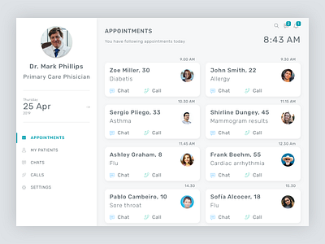

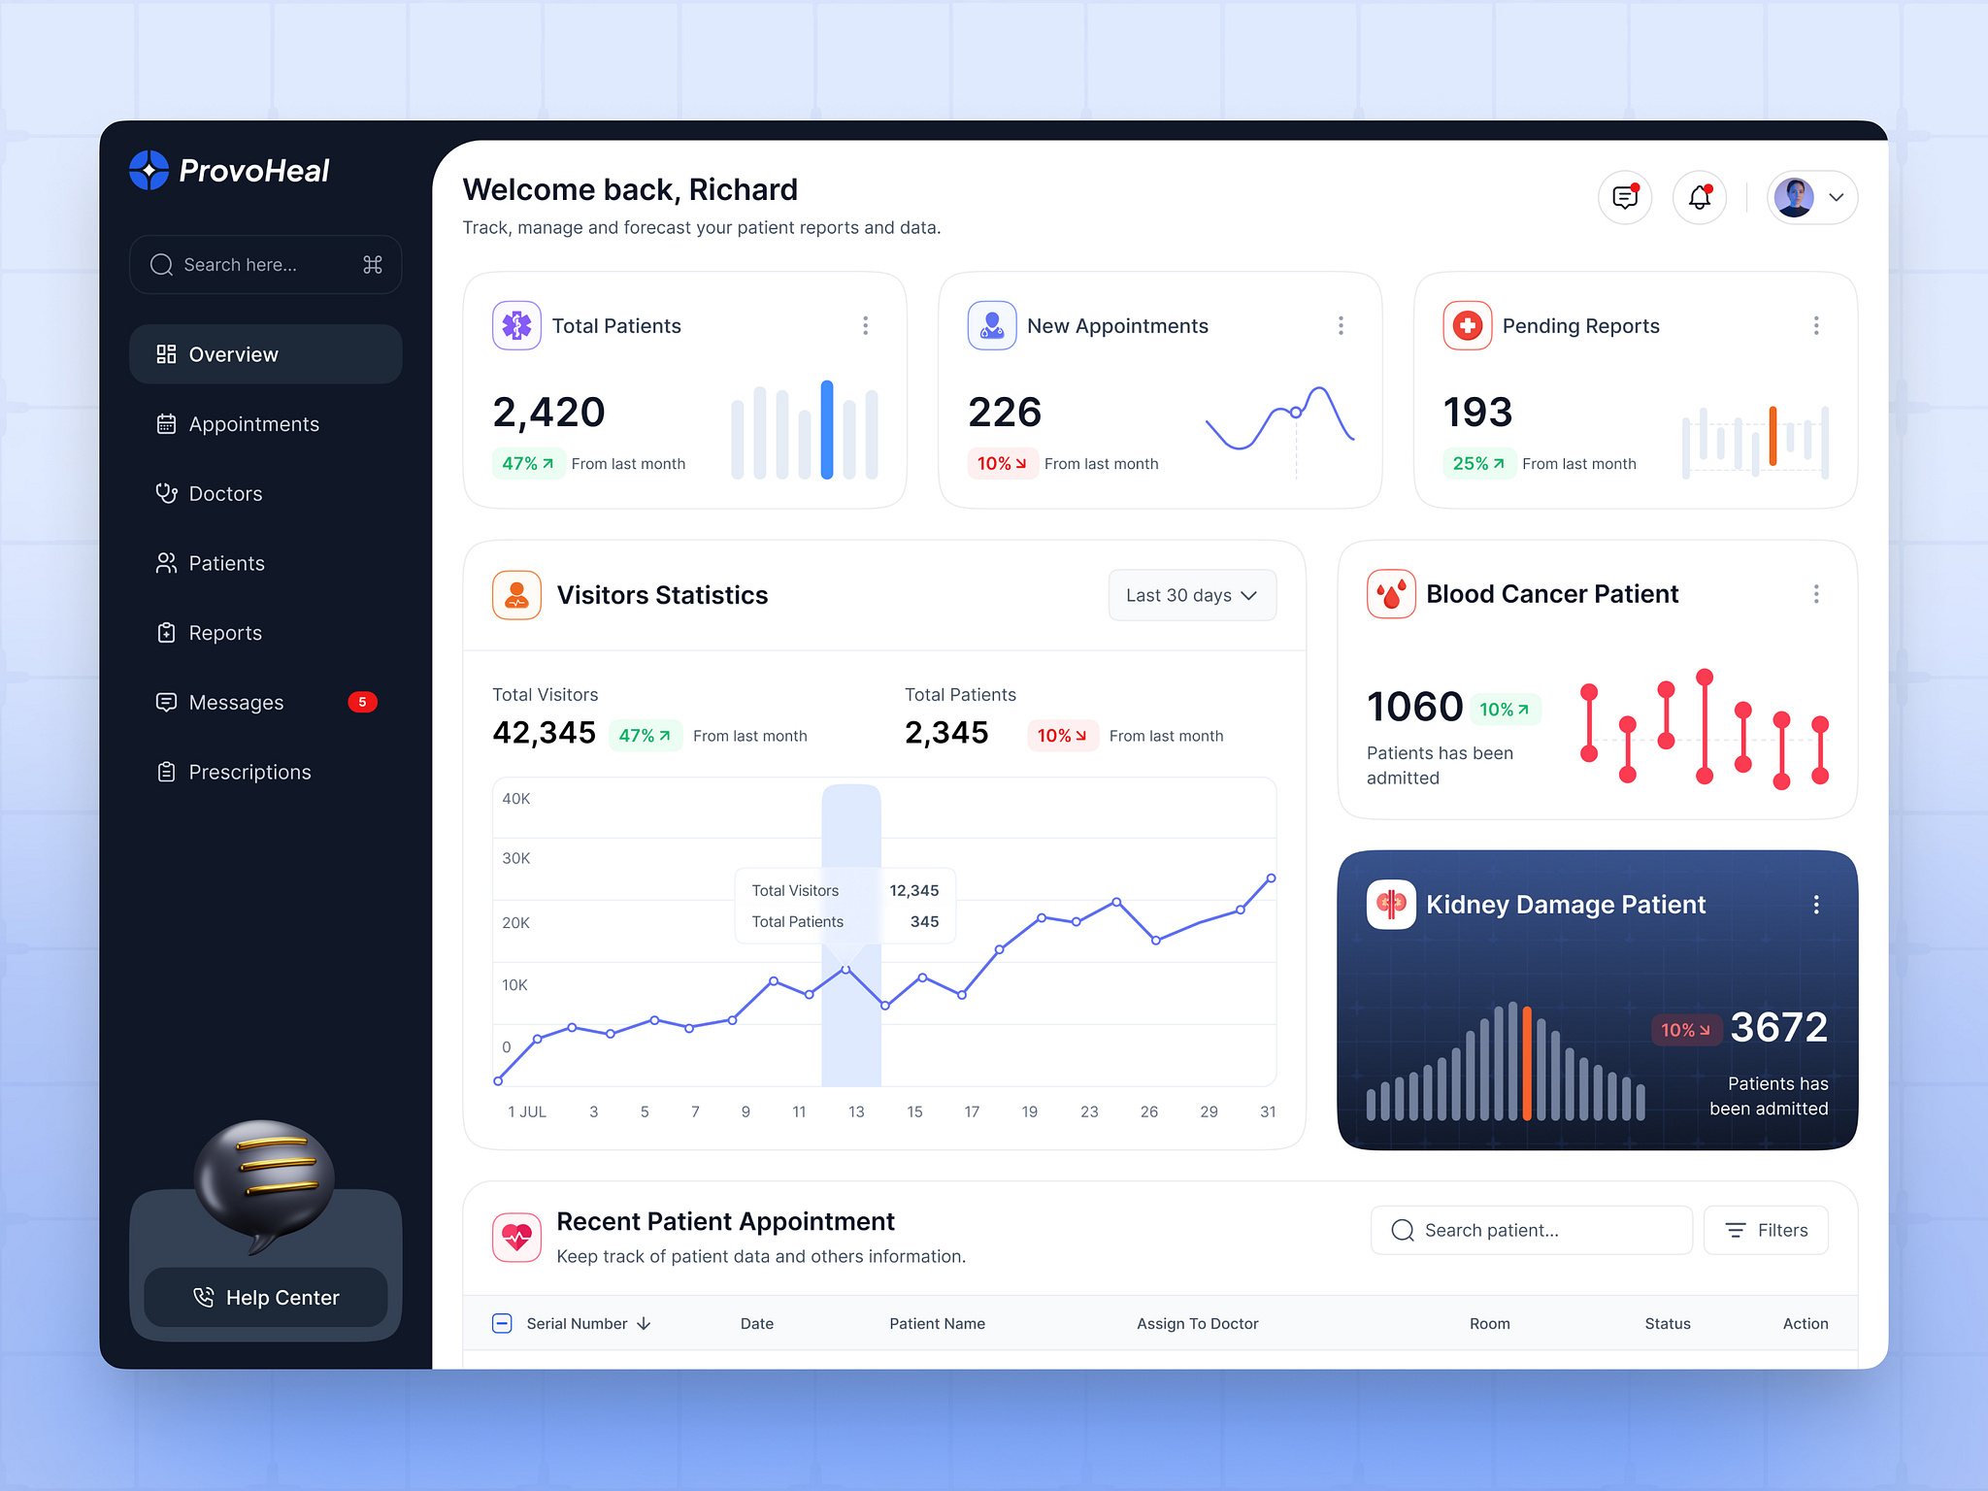

5

**Doctor can:**

✔ View today’s appointments  
✔ Manage schedule  
✔ Track pending requests

**📋 Booking Records — Appointment History**

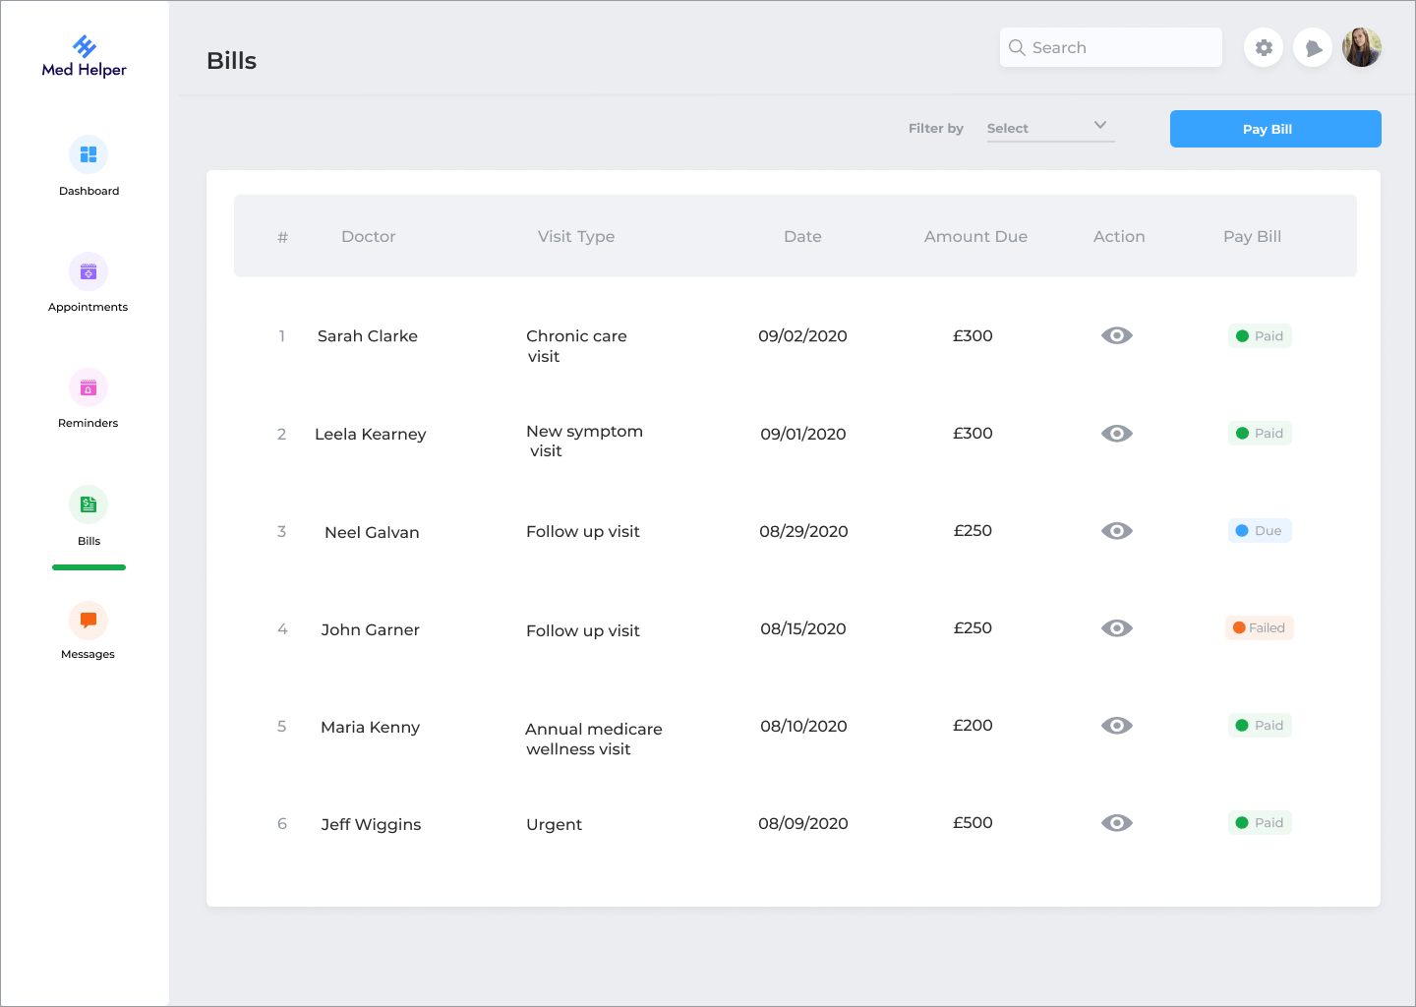

5

**Features:**

✔ Search bookings  
✔ Status tracking  
✔ Edit / confirm / complete

**🏥 Services Page — Clinic Offerings**

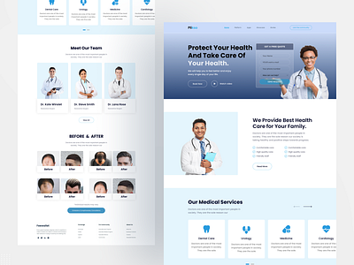

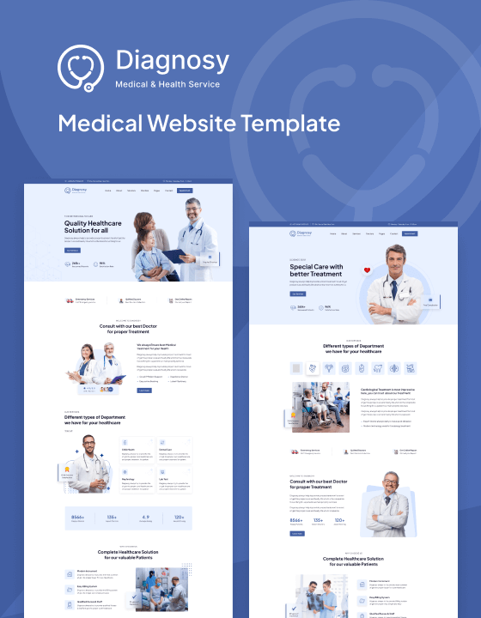

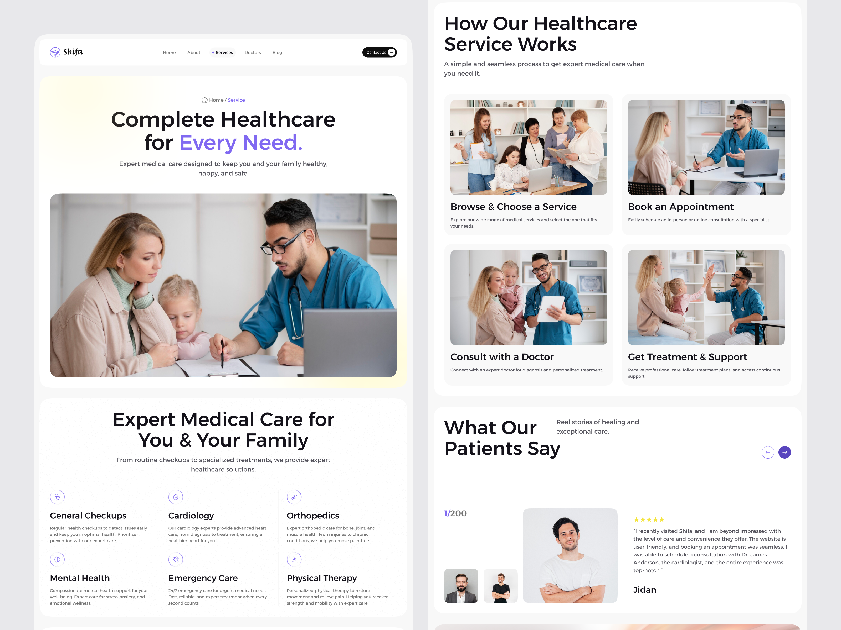

5

**Shows:**

✔ Operation theatre  
✔ Maternity care  
✔ Pharmacy  
✔ Healthcare services

**📅 Appointment Booking System — Slot Based**



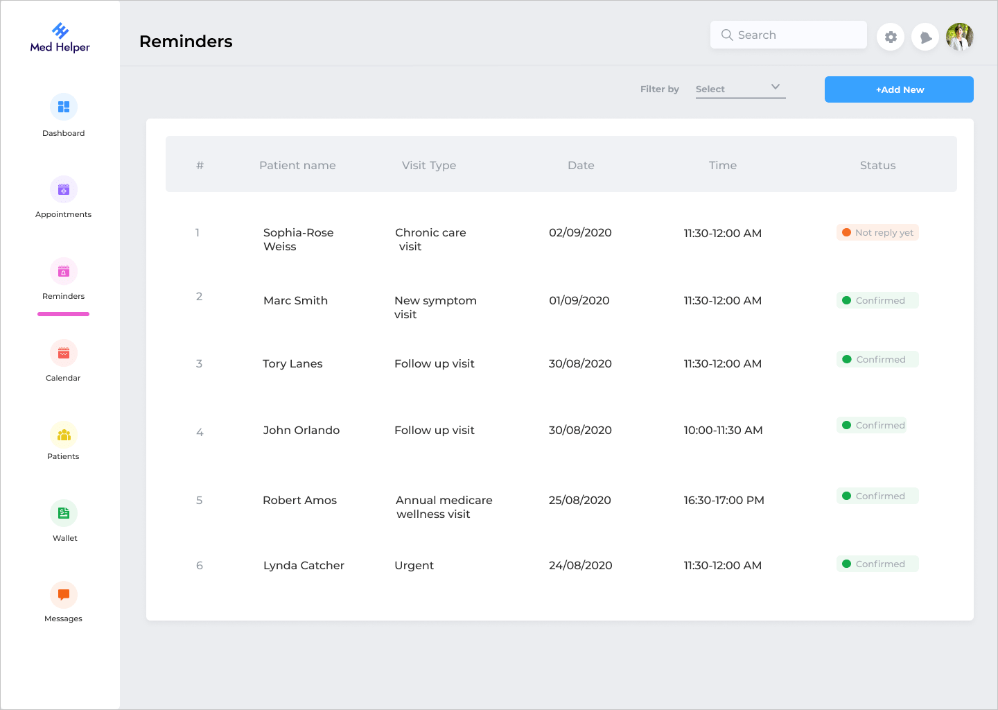

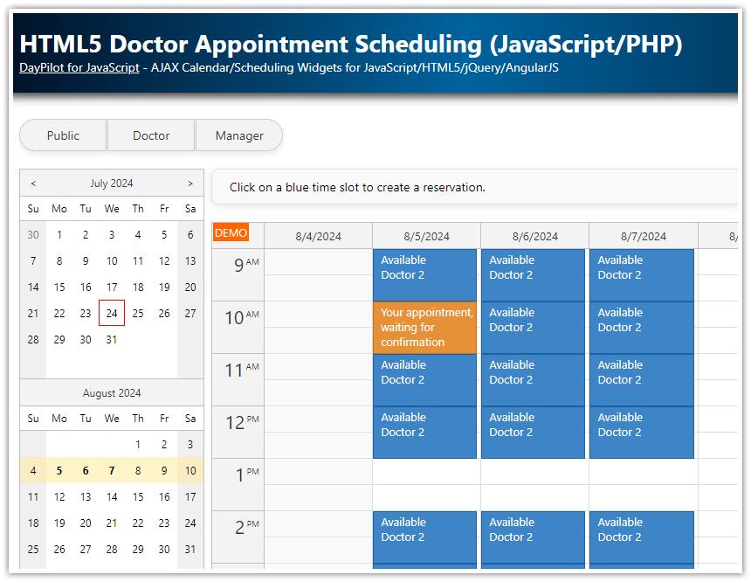

5

**Patient can:**

✔ Choose date  
✔ Select time slot  
✔ Add symptoms  
✔ Book instantly

**🛠 Tech Stack**

* Frontend: HTML, CSS, Bootstrap
* Backend: PHP
* Database: MySQL

**🚀 Core Features**

✅ Multi-role system (Admin, Doctor, Patient)  
✅ Real-time appointment management  
✅ Slot-based booking  
✅ Status tracking  
✅ Clean modern UI  
✅ Fully functional HMS workflow

**📈 Perfect For**

✔ Academic projects  
✔ Portfolio showcase  
✔ Real clinic demo  
✔ Startup MVP